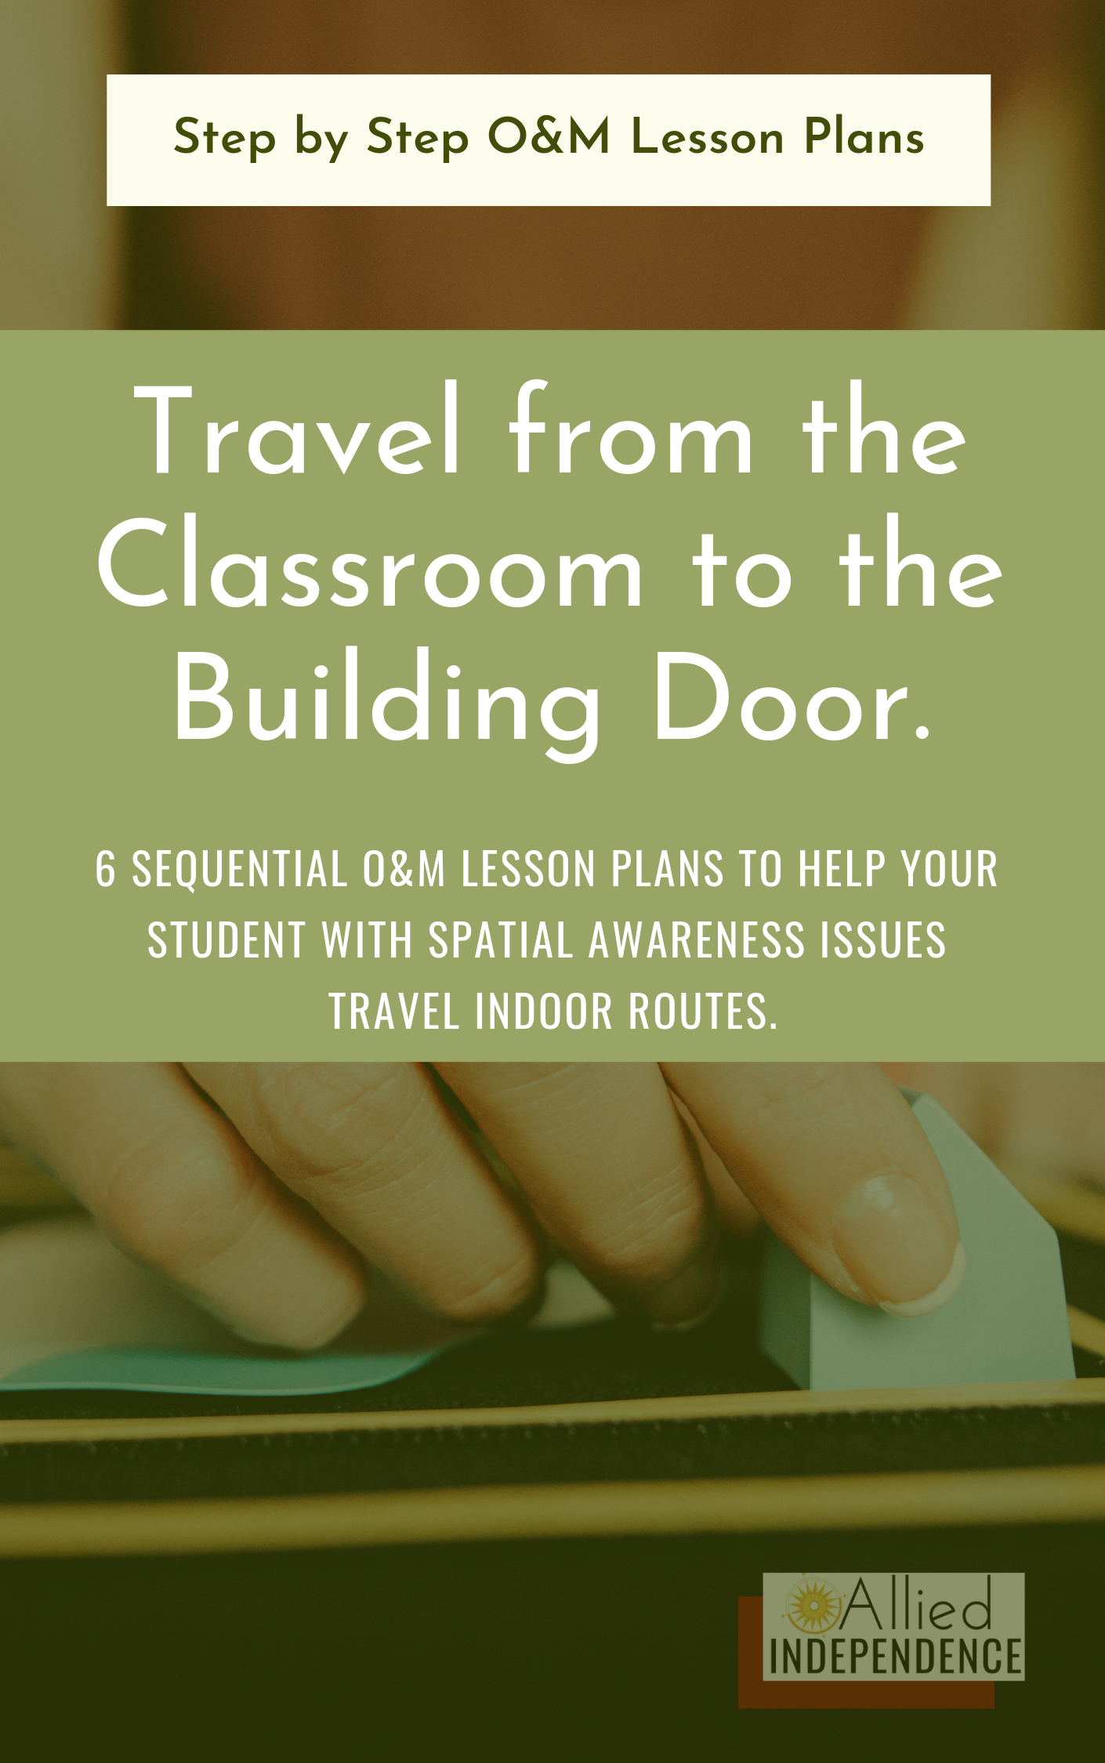

Objective: By the end of these lessons, Student will travel from their classroom to the front door of their classroom building.

Materials Needed:
- Tactile map of the route from the classroom to the front door of the Students’ classroom building.
- Braille Writer or other materials needed to create a list in the students’ literacy medium.

Lesson Plan Sequence:
Lesson 1: Create a tactile map of the route with the Student.
Lesson 2: Practice walking the route using the tactile map.
Lesson 3: Student will help create written directions of the route.
Lesson 4: Student will use written directions and/or tactile map to travel the route.
Lesson 5: Student will use only 1 support (written directions or tactile map) to travel the route.
Lesson 6: Student travels the route without written or tactile supports.

Data:
Use the table below to take data on this set of lesson plans.

Route, # of Prompts by type (V= Verbal, T= Touch, O=Object, I= Independent), Notes
Route/Lesson | V | T | O | I | Notes

Notes: As always, it is the Orientation and Mobility Specialists’ discretion to repeat or modify the lessons as necessary. Allied Independence does not assume responsibility for how the lesson plans are taught or the results thereof.

LESSON 1: Create tactile map of route.

Objective: Given step by step directions and practice traveling the route from their classroom to the building door, Student will assist in creating a tactile map of the route.

Materials Needed:
- Written step by step directions of the route using the “landmark, action” in 1st person language, for each step. i.e. “Step 1. Starting at the door of my classroom (landmark), I turn right and travel down the hallway. (action)” Step 2. “At the end of the wall (landmark), cross the hall and turn left (action)”.
- Tactile map materials.

Lesson Sequence:
- Introduce lesson.
- Introduce new route.
  - Walk the route at least one time with student, giving step by step instructions and prompting as necessary to complete the route correctly.
  - Record the student traveling the route in their favorite media (audio or video).
- Travel to O&M classroom to be seated.
- Create Tactile map of the route with the student.
  - Review the route verbally using the step by step set of directions and recorded video/audio.
  - Introduce tactile map materials to student.
  - Using the format “Landmark, action” for each step, allow the student to choose the landmark piece (give 2-3 choices for each landmark). Use hand under hand to help them place it on the board correctly.
- Review the map.
- Check for understanding.
  - Ask the student questions that will let you know where their concept gaps are.
  - Fill the concept gaps at that moment and recheck for understanding.
- Summarize lesson.
  - Finish up the lesson by summarizing the key points of the lesson together.
  - Summary examples: “What did we do today?”, “Today, we traveled the route from your classroom to the front door of your classroom building. Then, we made a tactile map of the route!”.
- End lesson
  - At the end of each lesson, I like to make sure the student feels successful with at least one part of the lesson and check for understanding one last time.
  - Examples: “Tell me two things you learned or got better at today.”. and “What are you proud of yourself for doing today?”

Lesson Plan 2: Practice walking the route using the tactile map.

Objective: Given verbal, tactile (touch prompts), and object (tactile map) support as necessary, Student will practice walking the route from their classroom to the building door.

Materials Needed:
- Tactile map of route.
- Step by step instructions (for O&MS)

Lesson Sequence:
- Introduce lesson
- Give the student the tactile map to follow along as you verbally give step by step instructions. (If needed forward or backward chain this activity.)
- Give the student the step by step instructions, making sure that they are on the same place on the map as you give directions.
- Practice the route.
  - Using the tactile map, have the student travel the route from their classroom to the building door. Check for understanding along the way.
- Summarize the lesson.
- End the lesson.

Lesson 3: Create written directions for the route from their classroom to the building door.

Objective: Using a recording of the route from their classroom to the building door, Student will help write their own route.

Materials Needed:
- Recording of the route.
- Braille Writer, pre-written cards in Students’ literacy medium, Picture Symbols, Tactile Symbols, or the appropriate combination of literacy mediums.
- O&M Specialist’s written step by step directions from Lesson 1.

Lesson Sequence:
- Introduce lesson.
- While seated at a table or desk, have student help write the route using the step by step “Landmark, Action” in 1st person format.
- Using the newly created written format, have the student travel the route.
  - Give prompts as appropriate.
- Check for Understanding.
  - Fill in any concept gaps and check for understanding again.
- Summarize Lesson.
- End Lesson

Lesson 4: Use written directions and/or tactile map to travel the route.

Objective: Using written directions and/or tactile map, Student will travel to travel the route from their classroom to the building door given X verbal prompts on X attempts at the route.

Materials Needed:
- Written directions
- Tactile map

Lesson Sequence:
- Introduce lesson.
- Starting at the beginning of the route, have the student explain the steps of the route.
- Have the student travel the route X amount of times, using the written directions and/ or tactile map as necessary, giving X verbal prompts (if necessary).
- Summarize Lesson
- End lesson.

Lesson 5: Use only 1 support (written directions or tactile map) to travel the route.

If your student used both the written directions and tactile map to travel the route in Lesson 4, Repeat Lesson 4, but use only 1 support to travel the route. Otherwise, skip Lesson 5.

Lesson 6: Student travels the route without written or tactile supports.

Objective: Student will travel the route from their classroom to the building door, given X prompts on X attempts.

Materials Needed: none!

Lesson Sequence:
- Introduce lesson.
- Using the written directions only when necessary, have the student list each step of the route from their classroom to the building door.
- Have the student travel the route from their classroom to the building door, using written directions or verbal prompts only when necessary.
- On each subsequent attempt at the route, reduce the prompts and/or remove access to the written directions.
- Summarize lesson.
- End lesson.

